Table of Contents
1. Pipeline FEED Scope Definition / Summary 2
2. Basic Concepts 4
2.1. Gas Gathering System 4
2.2. Gas Processing Plant (GPP) – 500 MMscfd 4
2.3. Methanol Production Plant 5
2.4. Floating LNG (FLNG) Facility 5
2.5. Product Export System 5
2.6. Produced Water Management 5
2.7. Utilities and Offsite Infrastructure 5
3. Pipeline Engineering 7
3.1. Pipeline Routing Philosophy 7
3.2. Liquid Management Strategy 7
3.2.1. Upstream Liquid Removal 7
3.2.2. Diameter Optimization 7
3.3. Receiving Facility Protection 8
3.4. Liquid Handling and Disposal 8
4. Specialized Survey Activities – to be undertaken by experienced third-party contractors 18

Abbreviation
 | s/n | Abbreviation | Meaning
 | 1.0 | AKAB | Akabel
 | 2.0 | BBOU | Bubouwe Bou Field
 | 3.0 | BCFD | Billion Cubic Feet per Day
 | 4.0 | BFPCL | Brass Fertilizer and Petrochemical Company Limited
 | 5.0 | CAPEX | Capital Expenditure
 | 6.0 | CSS | Cascading Style Sheets
 | 7.0 | DCS | Decision Concept Selection
 | 8.0 | EIA | Environmental Impact Assessment
 | 9.0 | ELEP | Elepa Field
 | 10.0 | FEED | Front-End Engineering Design
 | 11.0 | FLNG | Floating Liquefied Natural Gas
 | 12.0 | FMEnv | Federal Ministry of Environment Nigeria
 | 13.0 | GETL | Global Environmental Technology Limited
 | 14.0 | GPP | Gas Processing Plant
 | 15.0 | HDD | Horizontal Directional Drilling
 | 16.0 | HTML | HyperText Markup Language
 | 17.0 | IoT | Internet of Things
 | 18.0 | KP | Kilometre Post
 | 19.0 | LNG | Liquefied Natural Gas
 | 20.0 | LPG | Liquefied Petroleum Gas
 | 21.0 | MMscfd | Million Standard Cubic Feet per Day
 | 22.0 | MMTPA | Million Metric Tonnes Per Annum
 | 23.0 | MTPD | Metric Tonnes Per Day
 | 24.0 | NGLs | Natural Gas Liquids
 | 25.0 | NMDPRA | Nigerian Midstream and Downstream Petroleum Regulatory Authority
 | 26.0 | NUPRC | Nigerian Upstream Petroleum Regulatory Commission
 | 27.0 | OKNU | Okpokunou Field
 | 28.0 | OPEX | Operational Expenditure
 | 29.0 | PLEM | Pipeline End Manifold
 | 30.0 | RAEC | Renaissance Africa Energy Company Limited
 | 31.0 | SBM | Single Buoy Mooring
 | 32.0 | Sckope | Sckopemate Konsult Limited

Pipeline FEED Scope Definition / Summary
The Front-End Engineering Design (FEED) scope covers the development of a provisional 20-inch, approximately 85 km DSV gas pipeline from the RAEC Okpokunou (OKNU) Field to the BFPCL Manifold at BBOU, traversing the challenging swamp terrain of the Niger Delta.
The final pipeline diameter and routing will be subject to confirmation based on the FEED studies, including flow assurance and route optimization.
The FEED execution will be undertaken by Epic Atlantic Limited, the contractor responsible for the Phase 1 BBOU–ELEP–AKAB pipeline project. This ensures technical continuity, integration with existing infrastructure, and effective utilization of prior project data and lessons learned.
To support the FEED activities, specialized survey and environmental studies will be executed by experienced third-party contractors as follows:
- Sckope Limited is proposed to undertake the Topographical and Geotechnical Surveys for the pipeline Right-of-Way (ROW), and
- GETL or Foisi Global takes the responsibility to conduct the Environmental Impact Assessment (EIA) in compliance with applicable regulatory requirements.
Both contractors possess extensive operational experience within the Niger Delta environment and are accredited by the Nigerian Upstream Petroleum Regulatory Commission (NUPRC) and the Nigerian Midstream and Downstream Petroleum Regulatory Authority (NMDPRA).
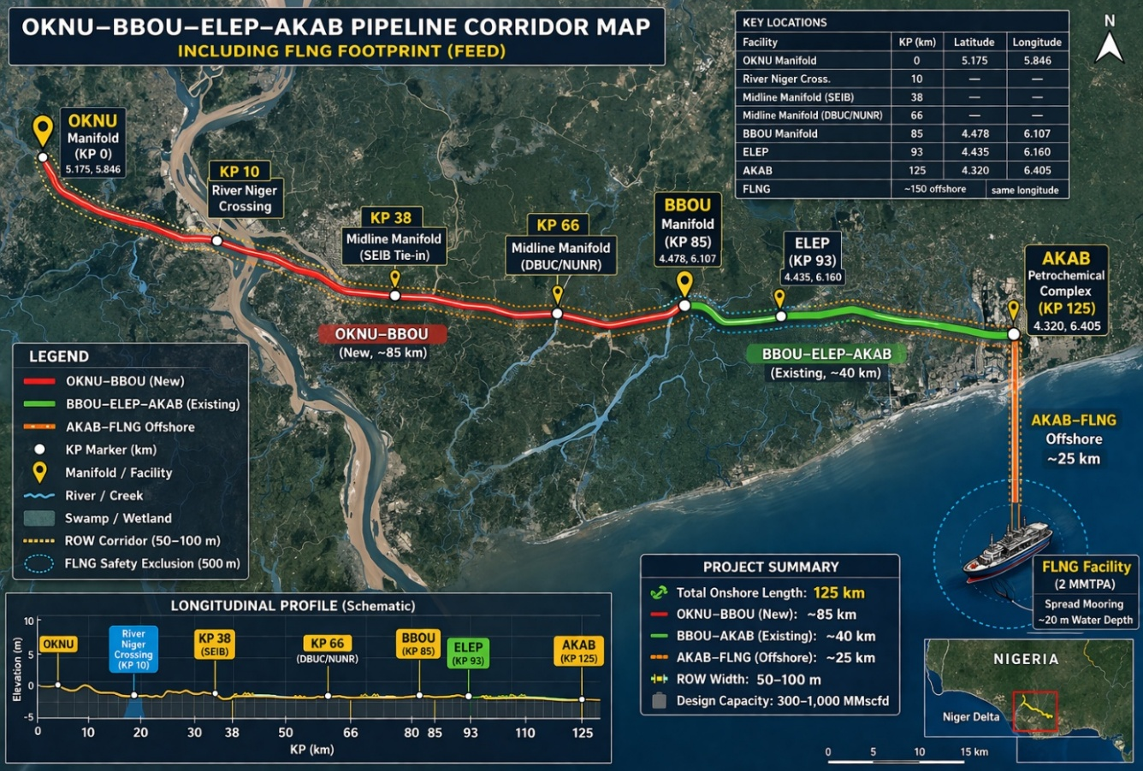

The survey scope is defined as follows:
- The OKNU–BBOU pipeline route is a new development; therefore, topographical, geotechnical, and EIA surveys are to be executed in full along the proposed corridor and associated facilities.
- The BBOU–ELEP–AKAB pipeline route, previously surveyed under Phase 1, will require repeat and supplementary topographical and geotechnical surveys to address route modifications, design updates, identified data gaps, and previously omitted sections.
These survey activities will provide the necessary baseline data to support detailed engineering design, environmental approvals, cost estimation, and project execution planning.

The FEED Link with the Survey
While the FEED will establish a technically robust, flexible, and scalable gas transportation and processing system, enabling:
- Efficient evacuation of OKNU gas
- Seamless integration with existing design & infrastructure
- Future expansion into a regional gas hub (up to 1 BCFD)
- Diversified monetization via fertiliser and LNG production
The Survey provides the data for the Design, under the oversight of the FEED, in shared vision and ownership mode:
- The pipeline will traverse predominantly swamp and riverine terrain, requiring specialized design considerations for constructability, integrity, and environmental protection.
- Define the pipeline route and Right-of-Way (ROW) requirements
- Establish a robust Design Basis Memorandum (DBM)
- Generate cost estimates (±15% accuracy)
- Identify project risks and mitigation strategies
- Provide input for Environmental and Regulatory approvals
- Develop execution philosophy and contracting strategy
New Pipeline: OKNU–BBOU
- Full Topographical Survey (ROW mapping, terrain profiling, obstacles)
- Full Geotechnical Investigation (soil stratigraphy, bearing capacity, swamp conditions)
- Full Environmental Impact Assessment (EIA)
- Repeat and supplementary Topographical Survey
- Updated Geotechnical Investigation
Base Case:
Schematics of Gas Supply from Okpokunou alongside Phase-1 Gas Supply
Satellite Imagery of Gas Supply from Okpokunou alongside Phase-1 Gas Supply
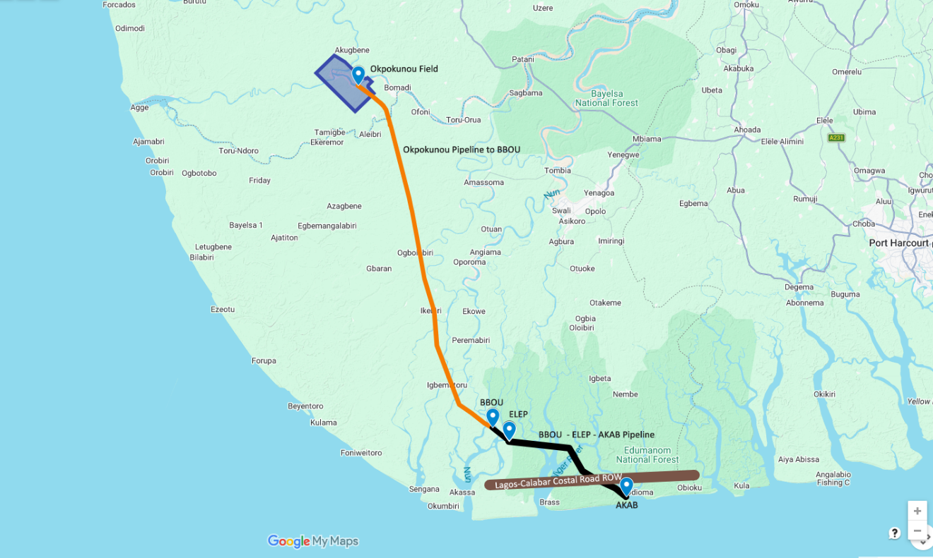

Basic Concepts
The pipeline diameter and length are preliminary and will be finalized based on detailed flow assurance studies, hydraulic simulations, and route surveys. However, current hydraulic assessments indicate a potential pipeline diameter in the range of 20-inch to 24-inch, depending on throughput optimization scenarios (up to 300 MMscfd, including future expansion cases); and utilization of midline slug catcher between OKNU and ELEP to manage transient flow conditions.
The downstream BBOU–ELEP–AKAB pipeline segment has been previously designed for a capacity of 340 MMscfd. With the introduction of additional gas volumes from OKNU, a detailed capacity assessment will be conducted to determine whether the existing system can accommodate the incremental flow.
Where required, pipeline resizing, looping, or compression options will be evaluated to ensure full system integrity and performance.
The OKNU–BBOU pipeline will therefore be technically integrated with the existing BBOU–ELEP–AKAB system, ensuring full alignment in:
- Design specifications
- Hydraulic performance
- Materials and corrosion philosophy
- Operational flexibility
This integration may necessitate revisions to previously established pipeline sizes, particularly in anticipation of a future gas hub capacity of up to 1 BCFD.
Gas from OKNU will contribute to a diversified monetization strategy, including methanol production and LNG export.
An offshore Floating LNG (FLNG) facility is proposed at approximately 20 km offshore in ~20 m water depth, utilizing modular topsides and a spread mooring system.
BFPCL Petrochemical Complex at Akabel – Facilities Overview
The integrated development at Akabel will comprise the following key facilities:

Gas Gathering System
- Network of pipelines and manifolds transporting gas from OKNU, BBOU, and ELEP fields to the central processing facility.

Gas Processing Plant (GPP) – 500 MMscfd
- Extraction of Natural Gas Liquids (NGLs)
- Delivery of lean gas to downstream facilities
- Includes:
  - Common front-end processing
  - Dedicated polishing units for Methanol and LNG

Methanol Production Plant
- Two trains, each rated at 5,000 MTPD
- Total production capacity: 10,000 MTPD

Floating LNG (FLNG) Facility
- Capacity: ~2 MMTPA LNG
- Feed gas: >200 MMscfd processed gas
- Location: ~20 km offshore, ~20 m water depth, complete with +25 km Feed Gas Supply Line from Gas Hub at AKAB to the FLNG
- Products:
  - LNG
  - Condensate
  - LPG (Butane & Propane)

Product Export System
- Export pipelines
- Offshore Single Buoy Mooring (SBM) system for methanol and NGL export

Produced Water Management
- Handling, treatment, and disposal facilities
- To be defined through Decision Concept Selection (DCS) studies

Utilities and Offsite Infrastructure
- Power generation systems
- Steam generation
- Product storage facilities
- Export jetty and marine infrastructure
- All required off-plot and support systems
Pipeline Design Philosophy – Flexibility & Expandability
While the primary objective of the OKNU–BBOU pipeline is evacuation of Okpokunou gas production, the design incorporates provisions for future network expansion through strategically located midline manifolds, which will also function as sectionalizing valve stations.
Planned Tie-in Points:
- KP 38, - for tie-in of SEIB production:
  - Confirmed tie-in point
  - Identified as a key gas supply node
- KP 66, - for tie-in of NUNR / DBUG production:
  - Conditional tie-in, subject to future development
Given proximity and routing efficiency, SEIB is considered the most practical near-term tie-in to the OKNU–BBOU pipeline, hence the midline manifold at KP 38
For NUNR and DBUC, a shared midline manifold near DBUC, subject to firm gas supply commitments, will be more cost effective than dedicated manifolds. The option of an independent pipeline network to gather NUNR & DBUC production to BBOU or ELEP will be evaluated during the FEED.
The Facilities Coordinates
Location | Latitude | Longitude | KP (km)
OKNU Manifold | 5.175 | 5.846 | 0
River Niger Crossing at KP 10 |  |  | 10
Midline Manifold at KP 38, near SEIB |  |  | 38
Midline Manifold at KP 66, near DBUC |  |  | 66
BBOU Manifold | 4.478 | 6.107 | 85
ELEP | 4.435 | 6.16 | 93
AKAB | 4.32 | 6.405 | 125
FLNG | 25 km due south of AKAB (same longitude)

Pipeline Engineering

Pipeline Routing Philosophy
The original concept for the Okpokunou Pipeline envisaged a direct connection to the Elepa Manifold (ELEP). However, subsequent routing assessments indicated that the proposed alignment would intersect the BBOU manifold corridor and run in close parallel with the existing/planned BBOU–ELEP pipeline in the downstream section.
It is therefore considered technically and economically prudent to terminate the pipeline at the BBOU manifold and utilize the planned BBOU–ELEP pipeline segment rather than constructing a dedicated line to ELEP.
This approach offers the following advantages:
- Approximate reduction of ~ 8 km in pipeline length
- Measurable CAPEX savings
- Reduced environmental footprint
- Minimized corridor congestion
- Improved constructability within Niger Delta swamp terrain

Liquid Management Strategy

Upstream Liquid Removal
The base case concept provides for removal of the majority of entrained liquids upstream at Okpokunou in order to:
- Reduce hydraulic loading
- Improve flow stability
- Minimize slugging risk
- Optimize downstream pipeline sizing
Accordingly, a slug catcher is proposed at Okpokunou.

Diameter Optimization
Early liquid removal may permit optimization of pipeline diameter. However, final sizing will be confirmed during FEED through:
- Steady-state hydraulic modeling
- Transient multiphase simulation
- Comparative evaluation of alternate slug catcher locations (inlet vs midline vs outlet)
- Sensitivity cases for turndown and ramp-up scenarios

Receiving Facility Protection
A slug catcher at the Pipeline End Manifold (PLEM) will provide protection against liquid slugs, thereby safeguarding downstream processing equipment and ensuring stable plant operations.

Liquid Handling and Disposal
The slug catcher facility will include full liquid-handling systems comprising:
- Condensate/NGL transfer facilities to AKAB for processing
- Produced water collection and handling system
- Storage and metering as required
- Produced water disposal options will include:
- Offshore discharge (subject to regulatory compliance)
- De-mineralisation for industrial use
- Other approved beneficial reuse options
Discharge into inland waters is not permissible under NUPRC and FMEnv regulations.
Pipeline Capacity and System Integration
The pipeline will be designed to transport up to 300 MMscfd of raw wellhead natural gas, made up as follows:
1. Design Throughput
The pipeline will be designed for a maximum capacity of 300 MMscfd of raw wellhead natural gas, comprising:
- 200 MMscfd from the RAEC-DSV Gas Sales and Purchase Agreement
- 70 MMscfd make-up gas on RAEC 270 MMscfd, in case the 70 MMscfd production will be coming from the fields whose production will be tied-in to the Okpokunou pipeline, or even from Okpokunou itself.
- 30 MMscfd design allowance, - for production upside
- Total Design Capacity: 300 MMscfd
The 300 MMscfd will flow to the BBOU manifold, from where the gas will join the BBOU enroute to ELEP via an existing/planned 20” x 8km to the ELEP M/F, enroute through 28-inch × 32 km trunkline to the Akabel Gas Processing Hub. At Akabel, the gas will be processed as feedstock for a Methanol Manufacturing Plant.

2. System Integration
Gas will flow:
- From OKNU to BBOU via the proposed 20” x ~ 85 km pipeline
- From BBOU through an existing/planned 20” × ~8 km line to ELEP
- From ELEP through a 28” × ~ 32 km trunkline to the Akabel Gas Processing Hub
At Akabel, the gas will be processed as feedstock for a Methanol Manufacturing Plant.
The OKNU–BBOU pipeline shall therefore be designed to reliably transport up to 300 MMscfd under all operating scenarios, while maintaining full flow assurance across the integrated OKNU–BBOU–ELEP–AKAB pipeline network, ensuring delivery of the target 500 MMscfd to the Gas Hub.
Pipeline Routing and Terrain
The approximately 85 km pipeline will traverse challenging Niger Delta swamp terrain and include:
- One major crossing of the River Niger, (a distributary of the Niger River), estimated at:
  - 200 m width
  - 9 m water depth
- Four (4) additional river crossings
- Eight (8) creek crossings
- Standard inlet manifold facilities at OKNU
- Terminal manifold facilities at BBOU
Special crossing methodologies (e.g., HDD, microtunneling, or cofferdam/trench methods) will be evaluated during FEED based on geotechnical and bathymetric investigations.

Pipeline Size Decision
The pipeline diameter shall be selected as the optimum commercial size capable of reliably transporting the forecast gas volumes to BBOU at a delivery pressure sufficient to ensure that the combined streams from BBOU arrive at the Gas Plant inlet at the required 60 barg.
The final diameter will be established through integrated hydraulic and flow assurance modelling of the full export corridor, including:
- OKNU–BBOU pipeline (new design subject line, currently assessed at 20” – 24”), pending pipeline route full preparatory survey, and RAEC confirmation gas source pressure.
- Existing Design 20” BBOU–ELEP pipeline, currently assessed at 24” – 28”
- Existing Design 28” ELEP–AKAB pipeline, currently assessed at 30” – 36”
System-wide validation will confirm that the selected diameter sustains the target throughput while maintaining pressure, temperature, and operability margins across all operating scenarios. Should modelling indicate hydraulic or flow assurance constraints within the downstream segments, re-sizing of the affected sections will be evaluated to preserve system integrity and performance.
Where the hydraulically optimal diameter differs materially from the commercially efficient size, competing options shall be comparatively assessed based on:
- Capacity robustness and future expansion potential
- Flow assurance risks (liquids handling, turndown, slugging, hydrate margin)
- CAPEX and lifecycle OPEX implications
- Constructability and swamp terrain constraints
- Uncertainty in production forecast and ramp-up profile
The selected diameter will therefore represent a balanced, risk-informed decision that optimizes commercial viability, operational reliability, and long-term system flexibility.

Scenarios of OKNU – BBOU Pipeline
- Length Profile: -
- OKNU to Niger River Crossing: ~ 10.68 km
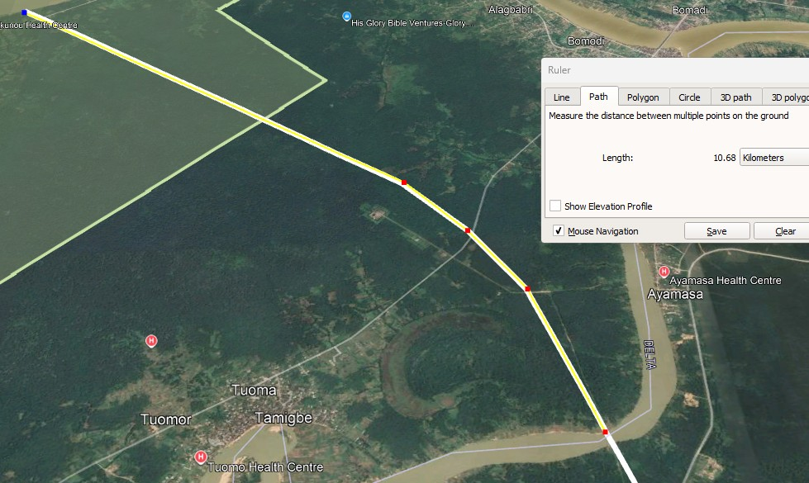

- Niger River Crossing: ~ 167.61 m
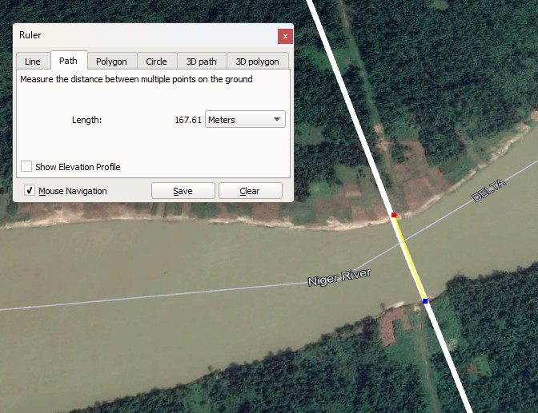

- River Niger Crossing to AKABEL: ~ 114.26 km
 | Scenario / Results Profile
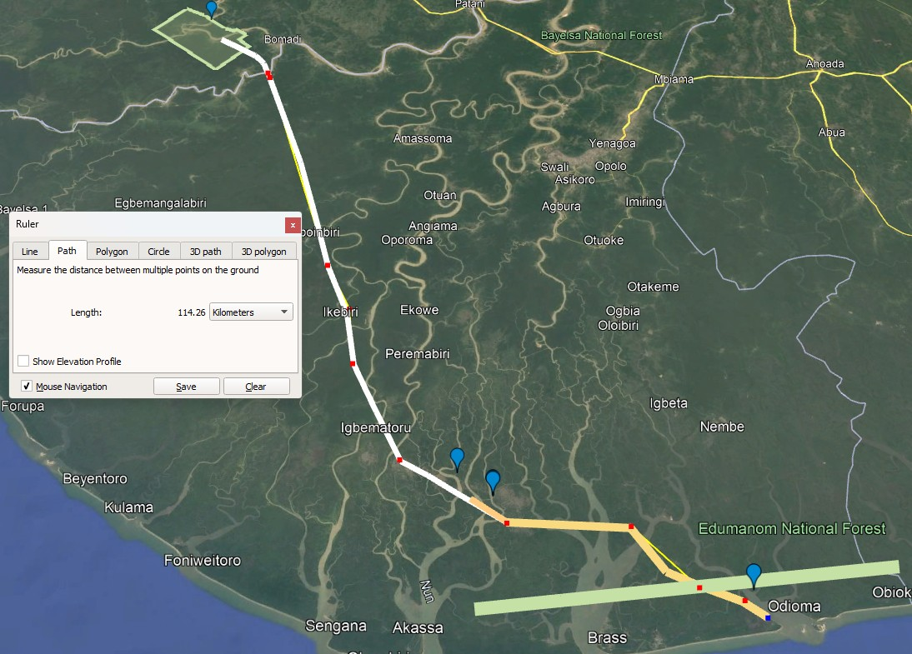 | - 18in Pipeline-run - 270 MMSCFD Deliverability:  - Source Pressure – OKNU F-MF: ~ 164 barg  - Arrival Pressure – AKAB: 60 barg  - 20in Pipeline-run - 270 MMSCFD Deliverability:  - Source Pressure – OKNU F-MF: ~ 130 barg  - Arrival Pressure – AKAB: 60 barg  - 24in Pipeline-run - 270 MMSCFD Deliverability:  - Source Pressure – OKNU F-MF: ~ 94 barg  - Arrival Pressure – AKAB: 60 barg
Manifold Facilities
Each midline manifold station shall be designed as a secure, autonomous installation incorporating:
Process Facilities
- Manifold headers for:
- Dedicated DSV custody/check metering for OKNU–BBOU bulk gas flow
Midline Manifolds (Future Tie-ins)
While the primary objective is evacuation of Okpokunou production, provision will be made for future tie-ins from:
  - SEIB tie-in (KP 38) – Firm
  - NUNR/DBUC tie-in (KP 66) – Conditional
Given relative proximity and routing logic, SEIB is considered the most practical candidate for tie-in to the OKNU–BBOU pipeline.
Also, given hydraulic and capacity constraints, only one additional supply node is pragmatically feasible within the current configuration without upsizing.
For NUNR and DBUC, subject to firm gas supply commitments, a separate pipeline network to BBOU may be developed. Conceptual schematics of alternative network configurations will be evaluated during FEED.
Process Design Basis
- Pipeline inlet pressure: ~100 barg
- Pipeline outlet pressure: ~60 barg
- Gas source: 3–4 clustered production wells
- Fluid composition: Raw natural gas containing approximately 2.0–2.5% CO₂
The presence of CO₂ at elevated pressure renders the service mildly corrosive (sweet service with CO₂ corrosion potential).
The FEED shall address:
- Material selection (linepipe, fittings, valves, internals)
- CO₂ corrosion modelling and mitigation strategy
- Internal corrosion allowance vs inhibition philosophy
- Integrity assurance framework
- Suitability for mildly corrosive (“sour-lean”) gas service

Concept Selection Methodology
The final configuration (slug catcher location, pipeline diameter, tie-in strategy, and system integration philosophy) will be determined during FEED through a structured techno-economic evaluation incorporating:
- CAPEX and OPEX comparison
- Lifecycle cost analysis
- Flow assurance modeling
- Operability assessment
- Constructability in swamp terrain
- Environmental and permitting considerations
- Expandability and future integration
The schematics of options for new pipeline networks are shown below.
Applicable Codes and Standards
The FEED shall comply with the latest editions of applicable international and local standards, including but not limited to:
Pipeline Design Codes
- ASME B31.8 – Gas Transmission and Distribution
- ISO 13623 – Petroleum and Natural Gas Pipeline Systems
- DNV-ST-N101 – Submarine/Swamp Pipeline Systems
Materials and Welding
- API 5L – Line Pipe Specification
- ASME Section IX – Welding Qualifications
Corrosion and Integrity
- NACE SP0169 – Cathodic Protection
- ISO 15589 – Pipeline Corrosion Control
Survey and Geotechnical
- ASTM Standards for soil testing
- BS 5930 – Code of Practice for Site Investigations
Environmental
- Nigerian EIA Act
- NUPRC Environmental Guidelines
- IFC Environmental & Social Performance Standards

Options for New Pipeline Networks:
Wholistic Gas Supply from ELEP, BBOU, and OKNU to the BFPCL/DSV Gas Processing Plant /
Gas Hub
Satellite Imagery – of New Pipeline Provision for Future Tie-in of NUNR & DBUC, - Two Options:
Option 1: DBUC to ELEP through BBOU / Option 2: DBUC direct to ELEP

Options for New Pipeline Networks (contd.):
Option 1: DBUC direct to ELEP - New Pipeline Network Provision for Future Tie-in of
NUNR & DBUC
Option 2: DBUC to ELEP through BBOU- New Pipeline Network Provision for Future Tie-in of NUNR & DBUC

Pipeline Facilities
The DSV pipeline system shall include, but not be limited to:
- Launch and receiving facilities (pig launcher & receiver)
- Gas metering stations (as required)
- Temporary cathodic protection (sacrificial anodes during construction)
- Permanent Impressed Current Cathodic Protection (ICCP) system
- Fibre Optic Cable (FOC) for:
  - Leak detection
  - Intrusion monitoring
  - Communications
- Associated block valves and sectionalization facilities
Water Separation (Subject to FEED Evaluation)
Provision shall be made for water separation at one of the following candidate locations:
- Pipeline inlet at OKNU
- Pipeline outlet at BBOU
- Akabel Gas Hub Station – Firm candidate
Final selection shall be based on:
- Techno-economic optimization
- Hydraulics and liquid hold-up modelling
- Operability and maintainability
- Corrosion management philosophy

Control & Power
- Remote Terminal Unit (RTU)
- Control Room / Field Auxiliary Room (FAR)
- Solar power system with battery storage (minimum 7-day autonomy)
- Electrical transformer and enclosed electrical room

Chemical Injection
- Corrosion inhibitor injection
- Biocide injection
- Methanol injection

Utility & Safety Systems
- Closed drain vessel
- Open drain tank
- Cold vent system for controlled depressurization of trapped volumes
- Earthing and lightning protection system
- Gantry structure with lifting accessories
- Weather shelter / guard house
- High-security perimeter fencing (e.g., Citadel, Heras, or equivalent)
- Navigation aids (aviation/marine lighting where applicable)

KIV Missed-out Pipeline EPC Scope
Crossing of Lagos–Calabar Coastal Road
The potential crossing of the planned Lagos–Calabar Coastal Road (+100 m ROW) by the ELEP–AKAB Pipeline shall be incorporated into the EPC Scope.
Crossing Philosophy
- Base case method: Horizontal Directional Drilling (HDD)
- Fallback method: Microtunneling (subject to geotechnical confirmation)
This requirement was inadvertently omitted from the original Pipeline Scope of Work (SoW) and shall be formally reinstated.
Strategic Preference
It is preferable for the pipeline to be installed prior to road construction.
If executed ahead of the road, engagement with the Federal Ministry of Works (Nigeria) would primarily focus on:
- Agreement on minimum burial depth
- Mechanical protection requirements
- Compliance with applicable highway crossing regulations
If the road is constructed first, trenchless crossing (HDD or microtunnel) will be mandatory.

Specialized Survey Activities – to be undertaken by the following proposed 3rd Party Experienced Contractors
s/n |  | Remarks
1 | Name | Sckopemate Konsult Limited
 | Role | Topographical & Geotechnical Survey
 | Address | #4, 1st Crescent, Rumuibikwe, Port Harcourt
 | Contact | Paul Nnamah - MD  0803 407 1116  Paul.nnamah@sckope.com
 | Remarks | Extensive operational experience within the Niger Delta environment  Accredited by the Nigerian Upstream Petroleum Regulatory Commission (NUPRC) and the Nigerian Midstream and Downstream Petroleum Regulatory Authority (NMDPRA).
2 | Name | Environmental Technology Limited (GETL)
 | Role | EIA Survey
 | Address | Block A2-9, Suite 117, Sura Complex  Simpson Street, Lagos Island , Lagos
 | Contact | Omotayo Seriki – Chief Operating Officer  0807 496 3021  omotayoseriki@yahoo.com
 | Remarks | Extensive operational experience within the Niger Delta environment  Accredited by the Nigerian Upstream Petroleum Regulatory Commission (NUPRC) and the Nigerian Midstream and Downstream Petroleum Regulatory Authority (NMDPRA).
3 | Name | Foisi Global Investment International Limited
 | Role | EIA Survey
 | Address | 55 Old Aba Road  Port Harcourt
 | Contact | Engr. Emiy B. Ikuru – MD/CEO  +234 706 937 1706, +234 705 736 2305  emiyikuru@foisiglobal.com
 | Remarks | Extensive operational experience within the Niger Delta environment  Accredited by the Nigerian Upstream Petroleum Regulatory Commission (NUPRC) and the Nigerian Midstream and Downstream Petroleum Regulatory Authority (NMDPRA).

  - Topographical Survey: -
- OKNU–BBOU Pipeline Route (New Survey)
- BBOU–ELEP–AKAB Pipeline Route (Repeat Survey due to route changes/omissions)

SCOPE AND SPECIFICATIONS
Scope will comprise mainly the following:
- Topographical Survey Report (including digital terrain models)
- GIS database and shapefiles (pipeline alignment, KP chainage)
- Updated survey datasets for BBOU–ELEP–AKAB
To this effect ITT will be duly issued containing Scope & Specifications, however note the following:
- The chainage will be done in the direction of flow from source to sink, from KP 0 to KP125.
- The pipeline should follow the optimized route to the Gas Pant Inlet Slug Catcher and not to the Methanol Plant.

  - Geotechnical Survey: -
- OKNU–BBOU Pipeline Route (New Survey)
- Geotechnical Investigation Report (boreholes, lab tests)
- BBOU–ELEP–AKAB Pipeline Route (Repeat Survey due to route changes / omissions)
- Soil classification along ROW
- Bearing capacity and settlement analysis
- Slope stability and erosion control
- Riverbank and shoreline protection requirements
- Groundwater and swamp interaction
SCOPE AND SPECIFICATIONS
To this effect ITT will be duly issued containing Scope & Specifications, however note the following:
- The soil sampling should not terminate at mud or soft clay but on hard rock.
- Please follow the specifications in the ITT.

  - EIA Survey: -
- OKNU–BBOU Pipeline Route (New Survey)
- Environmental sensitivity mapping
- Biodiversity and habitat impact assessment
- Community and socio-economic considerations
- Spill prevention and response planning
- Regulatory compliance framework
SCOPE AND SPECIFICATIONS
Again, the ITT will be duly issued containing Scope & Specifications, however note the following:
  - The exercise will involve 2 seasons, wet and dry seasons
  - The Scope of Work defines the requirements for conducting a full Environmental Impact Assessment (EIA) for the proposed OKNU–BBOU gas pipeline (~85 km) and associated facilities within the Niger Delta swamp terrain.
The assessment shall comply with:
- Federal Ministry of Environment Nigeria EIA Act Cap E12 LFN 2004
- Department of Petroleum Resources (now NUPRC) Environmental Guidelines
- International Finance Corporation Performance Standards
- World Bank Environmental & Social Framework (ESF)
The EIA shall cover the full lifecycle impacts of:
Pipeline System
- 20”–24” gas pipeline (~85 km) from OKNU to BBOU
- Design throughput up to 300 MMscfd (expandable)
- Swamp, riverine, and floodplain terrain
Key Facilities
- OKNU Manifold (KP 0)
- River Niger Crossing (KP 10) – critical sensitivity zone
- Sectionalising Valve / Midline Manifolds:
  - KP 38 (SEIB tie-in)
  - KP 66 (NUNR/DBUC tie-in)
- BBOU Manifold (KP 85)

Downstream Integration
- BBOU–ELEP–AKAB pipeline system
- Akabel Petrochemical Complex
- Offshore FLNG (~20–25 km offshore)

